Experiment 1

Name : Veeransh Shah

Reg No: 221070063

PL1 Lab

Aim:

There were several aims in this experiment

1. To find the square root of any number
2. Sum of elements of an array using recursion method
3. To find the Fibonacci series till a given Number
4. To find all the prime numbers in the given range of numbers

Code and Output:

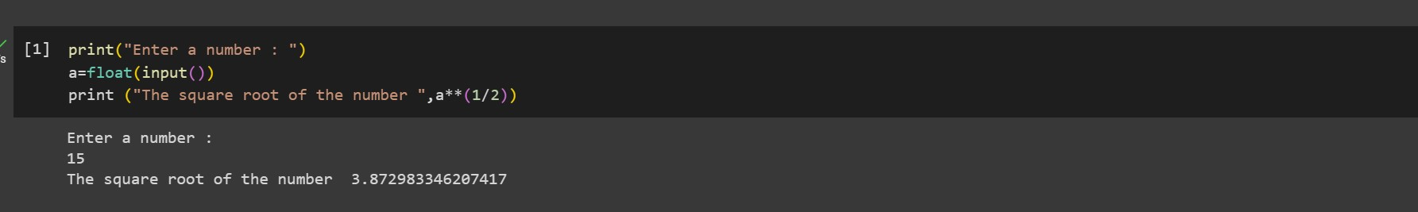

The first code which aims to find the square root of a particular number entered by the user, so for that firstly we have to take the input of a number in the code, and later square root that number (a\*\*(1/2))and print it.

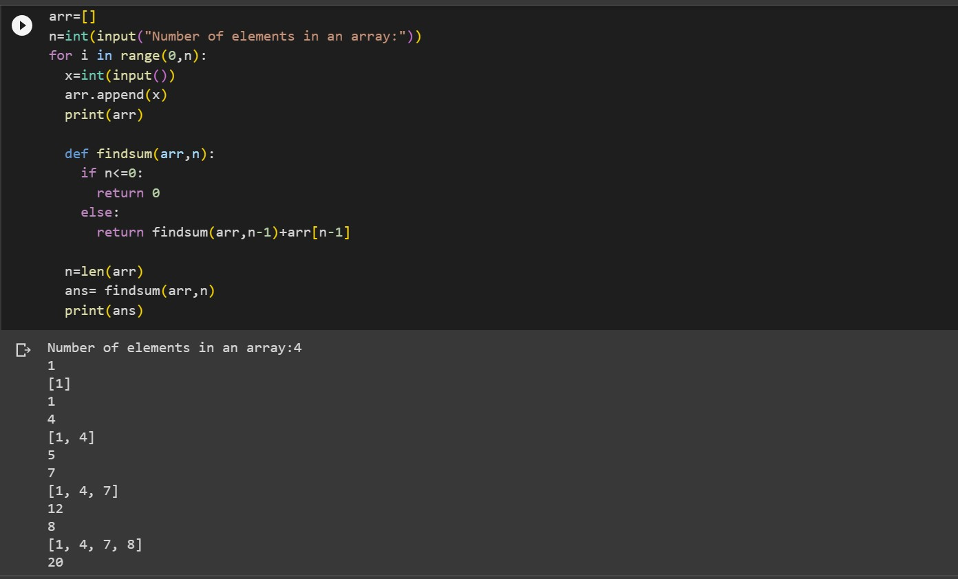

The second code aims for adding the elements in arrays using recursion method, where the user enters number of elements and after each element is entered there is a sum provided in the output, which gives us the sum of the elements of the arrays through recursion method.

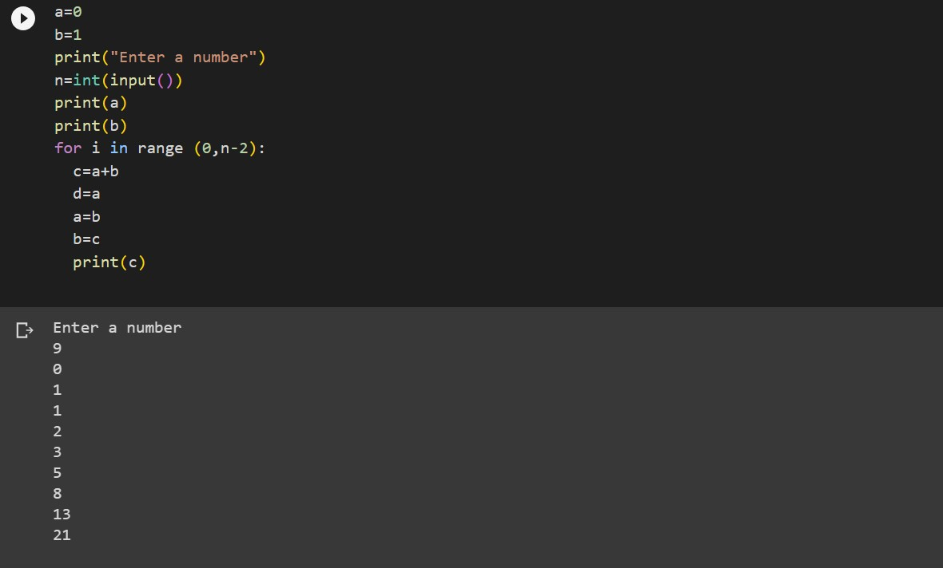

This code is for Fibonacci series where the user enters the number to be printed and, later those many numbers are printed in the output adding the previous number printing it as the next number, giving us a Fibonacci series.

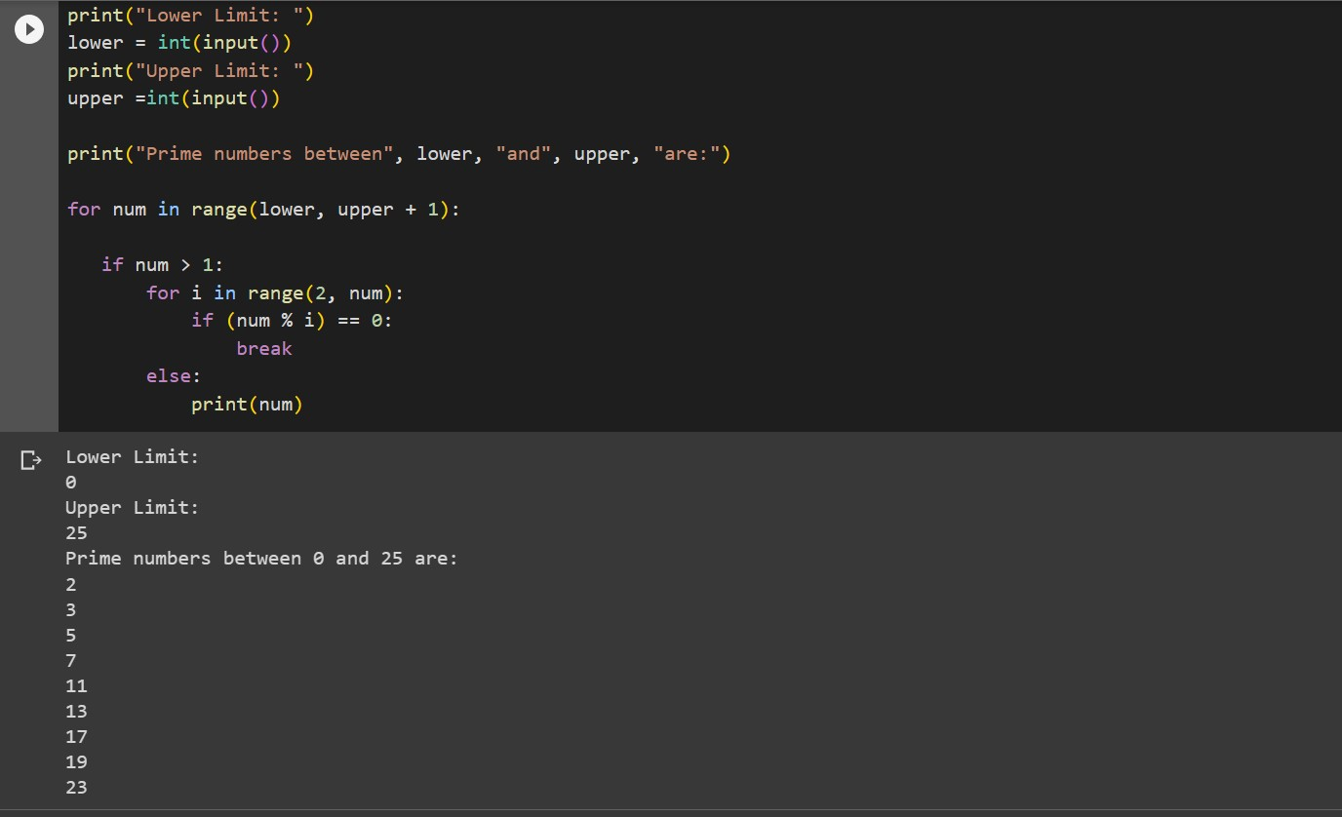

This code aims to print the prime numbers from the upper limit to the lower limit entered by the user and all the prime numbers from the lower limit to the upper limit are printed in the output.

Conclusion:

Through this experiment we learnt more about many different functions and libraries of Python.

This experiment helped us to think more on the logic.